**Documentation of XSLT:**

The code can be found on this location: <https://github.com/apoorva-ovgu/jenkins_acn>

* 1. Code file: XformWithXSL.java
  2. Location of XMLs: reports/<file>.xml
  3. Location of XSL: Root directory
  4. Location of output: reports/<file>_transformed.html
  5. Methods:
     1. Main: Searches for all XML files, and passes them one by one to a method called xsl
     2. Xsl: Uses java's xml libraries and transforms the xml files. In the end, calls checkResults()
     3. checkResults: Unit test method. Code to generate a CSV with data about which files were converted successfully and which were not.

1. Results:
   1. Input - XML File:

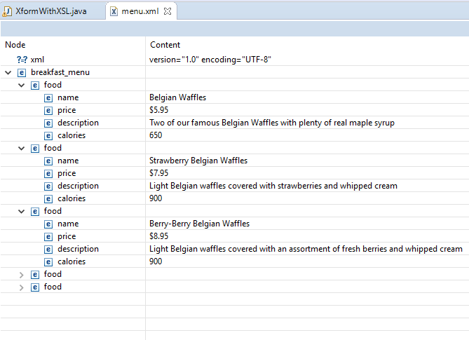

* 1. Output – formatted XML:

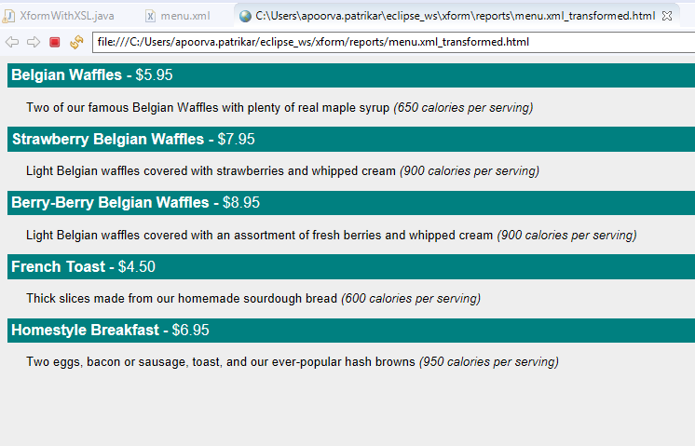

1. Unit Test result (in CSV as discussed:

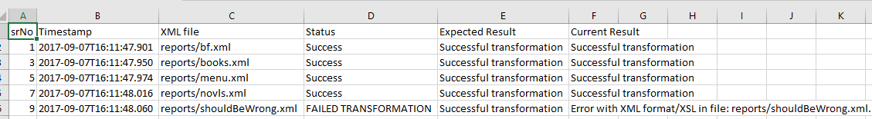

By,

Apoorva Patrikar, Accenture